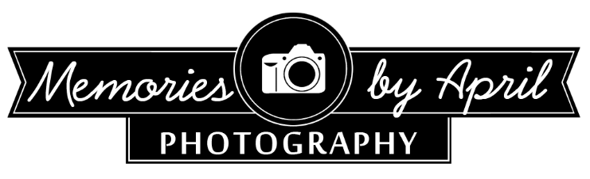

BOUDOIR MODEL RELEASE/CONTRACT

HELLO, BEAUTIFUL!

YAY for teamwork! I don't often do "trade"/"TFP"/"promotional" work, but in the rare event that I do, it's with brilliant and talented people-- SO KUDOS! I love working together with people as special as yourself.

I have the utmost respect for those that I collaborate with...and I will treat your work as such. When using an image you participated in on social media, I will tag your handle appropriately. If we have collaborated for a third-party brand, note that it is not their obligation to tag you, though I encourage them to. Anything on the Memories by April & Boudoir by Memories by April Instagram, Facebook, or Blog will be tagged using the information you've provided.

I will never post anything that I don't truly believe is a representation of everyone's best work. If you ever have any issue with anything that I post, please contact me directly and be open in communication with me.

Given a trade collaboration, I will use my full discretion to select images to retouch and release. Note that trade work does not have a guaranteed timeline as this is my full time profession and paid jobs must take precedence. That said, I am truly in love with my job and I promise to turnaround your image release within the best of my ability. Your images WILL see the light of day.

My philosophy for trade work is "you scratch my back, I'll scratch yours"! I'll promote you, and it would be oh-so-nice if you would promote me by means of sharing our finished product with your followers and properly crediting everyone involved (hair stylists, makeup artists, photographer, wardrobe, etc etc etc). The best way to make a project successful is pulling all of our efforts to promote it.  I will credit you in social media and on my blog. So please be sure to fill out the accurate information in the model release below

MODEL RELEASE

Full Model Name *

­­­­­­­­­­­­­­­­­­­­­­

First Name: __________________________________

Last Name: ___________________________________

Email Address *: _______________________________________________

Social media accounts to tag: _____________________________________

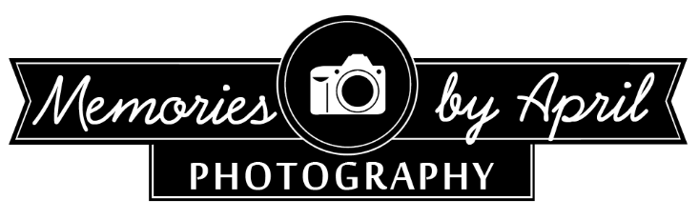

Being a client or model for April Estrada of Memories by April & Boudoir by Memories by April, I grant permission for my images to be used in print or digital form on the photographer's blog, website, social media accounts (including Pinterest, Instagram, Facebook, and Twitter), and printed sample items for studio, advertisements and promotions. While reasonable effort will be made to properly credit images appearing in print and digital format on other platforms, it is understood that my name may not be included/credited in every form of publication. I also understand that April Flores of Memories by April & Boudoir by Memories by April cannot be held responsible for the misuse or discredit of my images by others once the images have been placed online in digital format. I further waive any and all rights to review or approve the images prior to their print or digital release for the photographer's use. I understand that I am able to use the images of myself taken by April Estrada of Memories by April & Boudoir by Memories by April for my own portfolio, personal print, and/or social media accounts, but only with proper credit given to April Estrada of Memories by April & Boudoir by Memories by April (Either by business name, Twitter/Instagram handle, Facebook tag, or website credit). I understand that I am not to alter the images in any way other than to crop for social media purposes. Filters and re-edits are **not** permitted. I understand that I will not be held liable for the misuse/discredit of the photographer's work by others once the images have been placed online in digital format by me, as long as I have done my part in properly crediting the photographer and any/all involved parties (wardrobe stylists, photographers, makeup artists, hair stylists, venue, jewelers, etc. etc.). If at any time I would like to revoke the use of my images by the photographer, I understand that I am responsible to pay the photographer's full rate for the session fee, hair and makeup artistry, wardrobe, and the entire collection of retouched digital downloads ($____250.00____ ). In doing so, I understand that the photographer will remove all of my images from their website/blog/social media, but that the photographer cannot be responsible for removing my images that may have been featured on a third party's website. I understand that, if I am a model represented by an agency or independent agent, I am solely responsible for making this information known to the photographer prior to shooting, and the photographer has agreed to the agency's terms prior to releasing any images to me. I am of legal age (18 years or older.) ONCE REVIEWED, PLEASE PRINT FULL NAME BELOW ACKNOWLEDGING AGREEMENT OF THIS RELEASE *

PRINT FULL LEGAL NAME: ________________________________________________

SIGNATURE: ________________________________________________

Today's Date * MM__________ DD__________YYYY__________